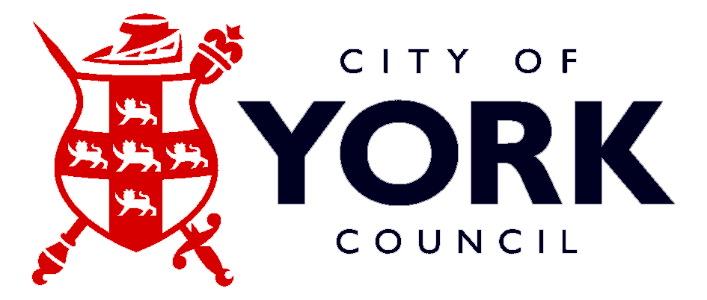

Vision Support

Specialist Teaching Team

SEN Services

Mill House

North Street

York

Tel: 01904 554302

Children and young people with reduced vision in York

- The Vision Support team provides specialist support for children with reduced vision whose sight cannot be corrected (improved) solely by the wearing of glasses
- Some children require professional medical vision support throughout their school life
- Medical intervention and Orthoptic advice is mainly carried out within the first nine years of life, as the child's visual system is developing.
- After that age many children are transferred to an optician of their choice for glasses to be prescribed should they require them
- Wherever possible we accompany families to eye appointments in order to gain first hand information on their child's visual progress
- We also feed back to the hospital regarding the impact, if any, that the child's vision is having on their learning

Type of support offered

We offer support to children, their families and schools by liasing closely with colleagues in schools and other agencies
Advice - to LA and educational settings on levels of support and deployment of staff
Continuing professional development -
regarding the educational implications of reduced vision
Curriculum support - advice on modifying curriculum materials, training and support in preparation of Braille materials
Equipment - recommendations and/or loan of specialist equipment
Buildings - advice to the LA and schools on minor and major modifications
Consultation and Support- interagency liaison, support groups
Mobility training- advice and support for individual children

Levels of Support

The level of our involvement varies considerably according to the child's needs
A weighting or priority system is used to determine support levels. This could be:
• On request
• Annual monitoring
• Termly monitoring
• ¹/₂ termly visits
• Weekly visits
• MuIti-weekly visits

Our aim is to enable children to take part as independently as possible in the life of their school

A copy of our referral form can be obtained by ringing Tel: 01904 554302 or download from

http://www.york.gov.uk/education/sen/

Team members

Peter Bowles Senior practitioner
Alison Prewer....Specialist Resource Technician

Contact details:

Vision Support
Specialist Teaching Team
Mill House
North Street
York
Y01 6JD

Tel: 01904 554697

Peter: 07788 631631

This information is available in other formats contact Tel: 01904 554302

