Busy Fingers Box
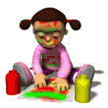

These are just some of the items which you might wish to put in your Busy Fingers Box. It is not an exhaustive list by any means, just use your imagination.

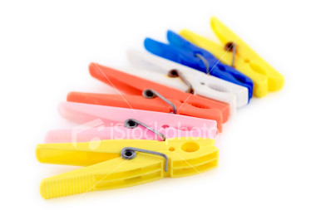  Pegs of various sizes | 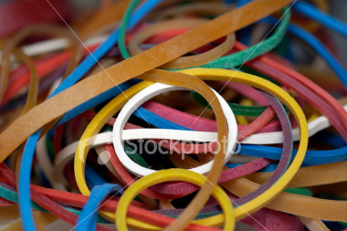  Elastic Bands | 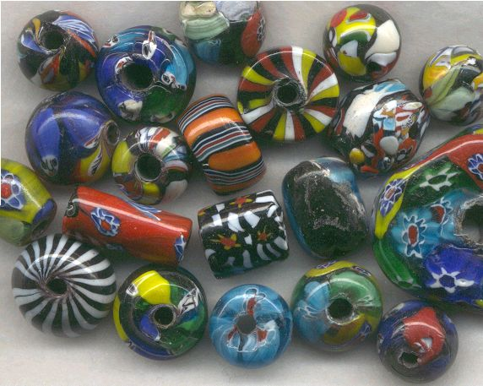  Beads for threading
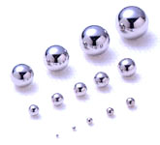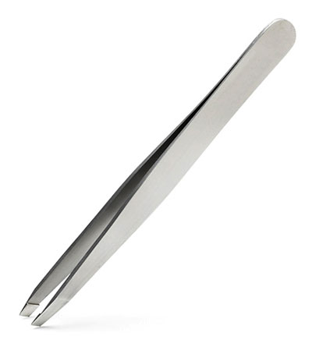  Ball bearings and tweezers | 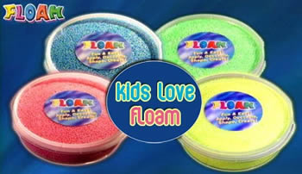  Floam | 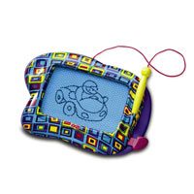  Doodle board
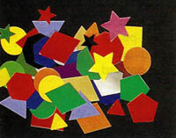  Gummed shapes | 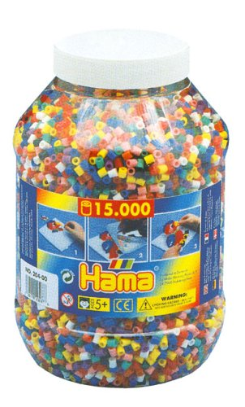  Hama Beads | 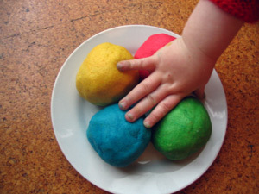  Playdough

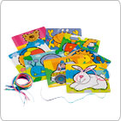  Lacing cards | 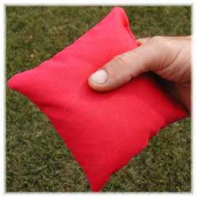  Bean bags | 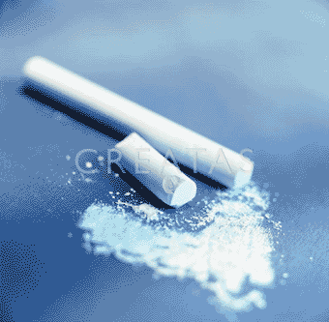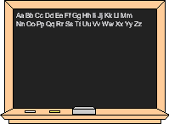  Chalk and blackboard
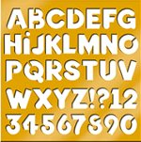  Stencils | 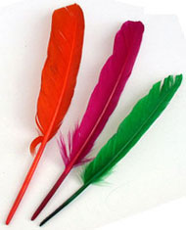  Feathers | 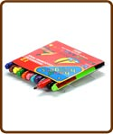  Handhugger pens
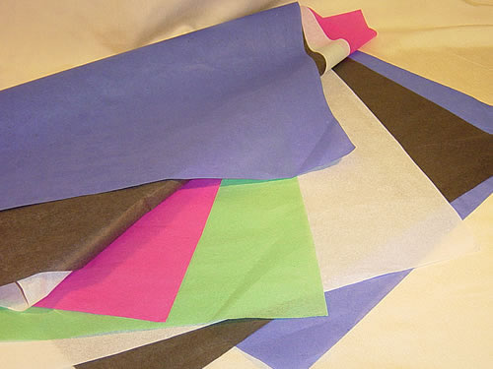  Tissue Paper Strips | 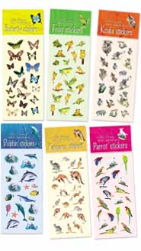  Stickers | 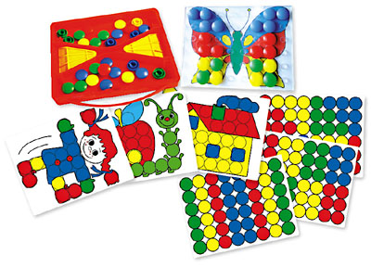  Peg boards

Busy Fingers Box

What do I do with these things?

1. Pegs –
- You need pegs of different sizes, clothes pegs, small bulldog clips, stationery clips etc. Get the children to use one hand only at a time. I usually get them to peg about 10 pegs of different sizes onto the sides of a gift bag. They might put them on with their left hand and take them off with their right.
- They can also try squeezing the pegs between the first finger and thumb (on each hand) then the middle finger and thumb and so on.

2. Elastic bands –
- Elastic gymnastics! – Start by putting 2 elastic bands (the same size) around the thumb, first and middle fingers, ask the child to open and close the fingers. Then add another 2 elastic bands and so on. The more you have on, the harder it is to move your fingers. These exercises help to develop the muscles which make the web space when writing.

3. Beads –
- Get beads of different sizes and thread. Ask the children to thread some beads onto their string. The smaller the hole obviously the harder it is to thread. Develops hand/eye coordination.

4. Ball bearings and tweezers –
- Put the ball bearings in one little box and ask the child to try and pick one ball bearing up at a time with the tweezers and place in a second small box. If this is too tricky try using Hama beads and tweezers.

5. Floam / Playdough –
- These products are great for squeezing and rolling which provides necessary sensory feedback and helps to develop hand strength. Ask the children to squeeze the dough and roll it with the palm of their hand.

6. Doodle board –
- The Doodleboard is just a way of children practising handwriting patterns or letters without having to commit them to paper. Provide some patterns and shapes to copy.

7. Gummed Shapes –
- Give the children a sheet of plain paper and ask them to make patterns or pictures with the gummed shapes. Just picking up on shape at a time, licking it and then sticking it down all help to develop hand/eye coordination and the pincer grip.

8. Hama Beads –
- Hama beads are good for pincer grip and hand/eye coordination. The children have patterned sheets to copy and peg boards to put them on.

9. Lacing cards –
- Also good for hand/eye coordination. Just give each child one card to lace.

10. Bean bags –
- Give a child 4-5 bean bags and place a container about 3 feet infront of them. Ask the child to try and get as many beanbags in the container as possible. (Hand/eye coordination)

11. Chalk and blackboard –
- If you can, try and wedge the blackboard between two tables and provide the child with a piece of chalk in each hand. Ask them to draw the same pattern with both hands at the same time on both sides of the board. This helps develop bilateral movement.
- Allow the children to draw patterns, shapes and letter shapes on the blackboard. The chalk gives sensory feedback and sound simultaneously.

12. Stencils –
- Children can use the stencils to make a picture. Helps develop pencil control and special awareness among other things.

13. feathers –
- Ask the children to try and balance a feather on different parts of their body. This helps to develop balance and coordination.

14. Handhugger pens –
- Hand hugger pens are the triangular shaped pens. These help the children to establish a better pencil grip.

15. Tissue paper strips –
- Place the child’s palm (at the wrist) on the end of a strip of tissue paper. Ask them to only use their middle finger to get the paper to scrunch up under their hand.
- Repeat, but this time place the side of the child’s hand on one end of the tissue strip and ask them to only use their thumb to scrunch up the paper and bring it under their hand.
- These activities really help to develop the hand arch, web space and muscle tone of the hand.

16. Stickers –
- Children love stickers. Just peeling them off provides an opportunity to develop fine motor skills and hand/eye coordination.

17. Peg boards –
- These can be peg boards where the child has to place pegs in the holes, maybe copying patterns.
- They can be the boards with plastic pegs already on where they have to stretch elastic bands between them to make patterns.

