

|  |
| --- |
| **Parish/Ward/Town:** |

|  |
| --- |
| **Last Review Date:** |

|  |
| --- |
| **Lead Contact:** |

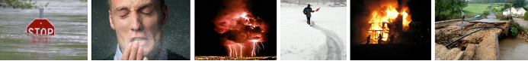

**Contents**

i. Record of Amendments 4

ii. Distribution List 5

iii. Key Community Contacts 6

iv. Contact pyramid 7

v. Emergency Box 8

Section 1: Community Profile 9

1.1 Map of Area covered by this CEP (incl flood zones if applicable) 9

Intentionally Blank Page 10

1.2 Population 11

1.3 Community Key Access Routes (including main bridges) 11

1.4 Main Rivers within the area 11

1.5 Becks within the area 11

1.6 Available Networks within the Community 11

1.7 Local Radio 12

1.8 Neighbouring Communities: Contacts 12

1.9 Methods for warning and informing Your Community 13

Section 2: Community Risks 14

2.1 Local Risks and Plan Triggers 14

2.2 Vulnerable Establishments 15

2.3 Vulnerable People (or people who may need additional assistance) 15

2.4 Areas Subject to Flooding (all types) (see location map) 16

2.5 Flood Alerts and Warnings (QUICK DIAL NUMBER ###) 16

Section 3: Rest/Welfare Centre 17

3.1 Rest/Welfare Centre 17

Section 4: Community Resources/Assets 18

4.1 Local resources 18

4.2 Emergency Volunteers 19

Section 5: Contact Details – Useful Organisations 20

Section 6: Incident Check Sheets 23

6.1 Community Emergency Team Agenda 24

6.2 Emergency Procedure 25

6.3 Rest/Welfare Centre Check Sheet 29

6.7 Data Protection – Consent Form 31

6.8 Post Incident Debrief form 32

# i. Record of Amendments

It is vital that you review and exercise your emergency plan regularly to ensure that it is up-to-date and fit for purpose.

Ensure any amendments are recorded here and please notify the Emergency Planning Unit (EPU) at North Yorkshire County Council (NYCC) immediately of any changes.

**Amendment list**

|  |  |  |
| --- | --- | --- |
| **Date** | **Details of Amendment** | **Name** |
|  |  |  |
|  |  |  |
|  |  |  |
|  |  |  |
|  |  |  |
|  |  |  |
|  |  |  |
|  |  |  |

**Training and Exercising**

|  |  |  |
| --- | --- | --- |
| **Date** | **Training / exercise summary** | **Name** |
|  |  |  |
|  |  |  |
|  |  |  |
|  |  |  |
|  |  |  |
|  |  |  |
|  |  |  |
|  |  |  |

# ii. Distribution List

|  |  |  |
| --- | --- | --- |
| **NAME** | **ADDRESS** | **CONTACT INFORMATION** |
| ..................Town/Parish Council  (Plus Emergency Team members and Emergency Box) |  |  |
| City of York Council Emergency Planning Unit | West Offices  Station Rise  York  YO1 6GA | Telephone: 01904 551039 / 551003  [Emergency.planning@york.gov.uk](mailto:Emergency.planning@york.gov.uk) |
| Environment Agency Yorkshire and North East | Coverdale House Amy Johnson Way Clifton Moor York | Telephone: 01904 692296 |
| North Yorkshire Police Control Room | Fulford Road York | Telephone: 101 |
| York Fire Station  &  North Yorkshire Fire and Rescue Service Control Room. | Kent Street,  York  YO10 4AH  Thurston Road Northallerton DL6 2ND | Telephone: 01904 616100  Telephone: 01609 780150 |
| Yorkshire Ambulance Service Control Room | Springhill Brindley Way Wakefield 41 Business Park Wakefield WF2 0XQ | Telephone: general enquiries  0845 124 1241 |
|  |  |  |

**Emergency Planning to distribute plans to Partners as appropriate**

# iii. Key Community Contacts

Those who have volunteered should understand their roles and responsibilities.

**Lead and Deputy for Community Emergency Team**

|  |  |  |
| --- | --- | --- |
| ***Name*** | ***Address*** | ***Contact Number(s)*** |
| **LEAD:** |  |  |
| **DEPUTY:** |  |  |

**Community Emergency Team**

|  |  |  |  |
| --- | --- | --- | --- |
| ***Name*** | ***Role*** | ***Address*** | ***Contact Number(s)*** |
|  |  |  |  |
|  |  |  |  |
|  |  |  |  |
|  |  |  |  |
|  |  |  |  |
|  |  |  |  |

.

|  |  |
| --- | --- |
| **Initial Meeting Location / Community Control Centre** | |
| **Address:** | **Contact Information** |
|  |  |
| **Backup Meeting Location** | |
| **Address:** | **Contact Information** |
|  |  |

# iv. Contact pyramid

A contact pyramid setting out a quick and efficient method to coordinate communications and easily spread information amongst your community, especially your Community Emergency Team (CET).

The pyramid works by the person at the top of the pyramid, usually the Lead/Deputy, contacting the next two people directly down the pyramid, and so on, until every person in the pyramid has been contacted. Where a person is absent, the person above should move down a level.

|  |
| --- |
|  |

|  |
| --- |
|  |

|  |
| --- |
|  |

|  |
| --- |
|  |

|  |
| --- |
|  |

|  |
| --- |
|  |

|  |
| --- |
|  |

|  |  |  |  |  |  |  |  |  |  |
| --- | --- | --- | --- | --- | --- | --- | --- | --- | --- |
|  |  |  |  |  |  |  | |  |  | | --- | --- | | |  | | --- | |  | | |

# v. Emergency Box

Communities should prepare and maintain an emergency box. It is important that the box be kept in a secure building that could be accessed by an appropriate community member during an incident.

Set out below is the location and contents of your community’s emergency box:

|  |  |
| --- | --- |
| **Location** | |
| **Address:** | **Contact Information** |
|  |  |

|  |  |
| --- | --- |
| **Contents** | |
| **Items** | **Checklist** *(tick)* |
| Up to date copy of this plan |  |
| Hi Viz Vests |  |
| First Aid Kit |  |
| Maps of the area   * 1:50,000 OS Landranger Series No. ............. * 1:25,000 Explorer Series No. ............... |  |
| A0 maps of community (including flood zones) |  |
| Copies of simple forms  • Incident Log  • Registration form  • Volunteer form |  |
| Torch (Wind up/Battery powered + spare batteries if required ) |  |
| Radio (Wind up/Battery powered + spare batteries if required ) |  |
| Candles and Matches |  |
| Latest copy of the Yellow Pages and/or Thomson Local |  |
| Other (*Please specify)…* |  |

# Section 1: Community Profile

## 

## 1.1 Map of Area covered by this CEP (incl flood zones if applicable)

## 1.2 Population

|  |  |
| --- | --- |
| Resident Population:- | *Total:* |
| Maximum Tourist Population:- |

## 1.3 Community Key Access Routes (including main bridges)

## 1.4 Main Rivers within the area

## 1.5 Becks within the area

## 1.6 Available Networks within the Community

Listed below are the various mobile telephone networks which are available within your community, (this is especially useful for the emergency services):

|  |  |
| --- | --- |
| **Network** | **Coverage** (Good, Average, Poor) |
| O2 |  |
| Vodafone |  |
| Orange |  |
| Three |  |
| Other: |  |

## 1.7 Local Radio

The local radio will communicate relevant public advice so it is important to TUNE IN!

|  |  |
| --- | --- |
| **Station** | **Frequency** |
| BBC Radio York | 103.7 FM |
| BBC Radio Leeds | 92.4 FM |
| Minster FM | 104.7 FM |
| Viking FM | 96.9 FM |

## 1.8 Neighbouring Communities: Contacts

Listed below are the contact details of neighbouring communities that may be able to provide help and assistance during an emergency:

|  |  |  |  |
| --- | --- | --- | --- |
| ***Parish*** | ***Contact person*** | ***Preferred method of contact*** | ***Community emergency plan?***  ***(yes or no)*** |
|  |  |  |  |
|  |  |  |  |
|  |  |  |  |
| Up to date info available via  <http://democracy.york.gov.uk/mgParishCouncilDetails.aspx?SLS=4&bcr=1> | | | |

## 1.9 Methods for warning and informing Your Community

Listed below are the various local methods for distributing info to the public:

|  |  |
| --- | --- |
| **Method** | **Responsible person / contact** |
| Twitter |  |
| Facebook |  |
| Website |  |
| Noticeboards |  |
| Other: |  |

# Section 2: Community Risks

## 2.1 Local Risks and Plan Triggers

Recorded below are various known/potential hazards and threats which could affect your geological area. - e.g. main roads, severe weather- snow etc, rail lines, aircraft, power plants.

|  |  |  |
| --- | --- | --- |
| **Hazard** | **Location / Details** | **Action Sheet** |
| Flooding |  |  |
| Severe weather |  |  |
| Power failure |  |  |
| Industrial accident |  |  |
| Transport accident |  |  |
| Fire |  |  |
|  |  |  |
|  |  |  |
|  |  |  |
|  |  |  |
|  |  |  |
|  |  |  |

**For information on your local risks, download your community risk register at:**

[**http://www.emergencynorthyorks.gov.uk/index.aspx?articleid=11778**](http://www.emergencynorthyorks.gov.uk/index.aspx?articleid=11778)

## 2.2 Vulnerable Establishments

This section lists establishments that may be particularly vulnerable to emergencies such as care homes, schools, caravan parks etc.

|  |  |  |
| --- | --- | --- |
| **Establishment** | **Address** | **Contact No(s).** |
|  |  |  |
|  |  |  |
|  |  |  |
|  |  |  |
|  |  |  |

## 2.3 Vulnerable People (or people who may need additional assistance)

|  |  |  |
| --- | --- | --- |
| **Name** | **Address** | **Contact No.** |
|  |  |  |
|  |  |  |
|  |  |  |
|  |  |  |
|  |  |  |
|  |  |  |
|  |  |  |

## 2.4 Areas Subject to Flooding (all types) (see location map)

|  |  |  |  |  |
| --- | --- | --- | --- | --- |
| **Location**  [Street/Road/Estate] | **Post Code or Grid Reference** | **Extent/ Other information** | Properties Affected | |
| **Which Properties** | **Total** |
|  |  |  |  |  |
|  |  |  |  |  |
|  |  |  |  |  |
|  |  |  |  |  |
|  |  |  |  |  |
|  |  |  |  |  |
|  |  |  |  |  |

## 2.5 Flood Alerts and Warnings (QUICK DIAL NUMBER .................)

|  |  |
| --- | --- |
| **SYMBOL** | **MEANING** |
|  | **Flooding is possible – be prepared**  **Flood Alert:**-  ..................................... |
|  | **Flooding expected – action required**  **Flood Warning:**-  .................................... |
|  | **Severe flooding – danger to life**  **Severe Flood Warning**:-  [*insert your local severe flood warning codes here*] |

FLOODLINE NUMBER

(QUICK DIAL NUMBER ..............)

# Section 3: Rest/Welfare Centre

## 3.1 Rest/Welfare Centre

The following building has been earmarked as an appropriate Rest/Welfare Centre in an emergency:

|  |  |  |
| --- | --- | --- |
| **PREMISES** | | |
| **BUILDING**: | | |
| **ADDRESS**: | | CONTACT NUMBERS:  *Tel no:*  *Fax no:* |
| **GRID REFERENCE**: | |
| **FACILITIES** | | |
| **ESTIMATED CAPACITY**: | | |
| **TYPE OF HEATING**: | | |
| **COOKING**:  **TOILET**:  **WASHING**:  **PARKING**:  **OTHER (*please specify)***: | | |
| **KEY HOLDERS** | | |
| **PRIMARY KEY HOLDER** | **ALTERNATIVE KEY HOLDER** | |

Add additional sheets as necessary

# Section 4: Community Resources/Assets

## 4.1 Local resources

|  |  |  |  |
| --- | --- | --- | --- |
| **Equipment/Resources** | **Location** | **Contact No.** | **Conditions of Use** |
|  |  |  |  |
|  |  |  |  |
|  |  |  |  |
|  |  |  |  |
|  |  |  |  |
|  |  |  |  |
|  |  |  |  |
|  |  |  |  |
|  |  |  |  |
|  |  |  |  |
|  |  |  |  |
|  |  |  |  |
|  |  |  |  |
|  |  |  |  |
|  |  |  |  |
|  |  |  |  |
|  |  |  |  |
|  |  |  |  |
|  |  |  |  |
|  |  |  |  |
|  |  |  |  |
|  |  |  |  |
|  |  |  |  |

Set out below is a list of equipment and resources which may be utilised during an emergency. Some of the equipment may require specialist skills/training and the use of appropriate safety equipment- these requirements are set out in the ‘conditions of use’ column.

## 4.2 Emergency Volunteers

Listed below are individuals who are willing to volunteer their specialist knowledge or practical skills and time during an emergency.

It is extremely important that volunteers understand that during an incident they should:-

* not endanger themselves or others
* assess the risk prior to any activity they undertake
* ensure their contact details are kept up-to-date
* be prepared to act quickly

|  |  |  |
| --- | --- | --- |
| **Name** | **Volunteer Role / Special Skills** | **Contact Details** (phone/email) |
|  |  |  |
|  |  |  |
|  |  |  |
|  |  |  |
|  |  |  |
|  |  |  |
|  |  |  |
|  |  |  |
|  |  |  |
|  |  |  |
|  |  |  |
|  |  |  |
|  |  |  |
|  |  |  |
|  |  |  |
|  |  |  |
|  |  |  |
|  |  |  |

# Section 5: Contact Details – Useful Organisations

|  |  |  |  |  |  |
| --- | --- | --- | --- | --- | --- |
| **Organisation** | | **Role** | | **Contact No.** | |
| ***Local Authorities*** | | | | | |
| City of York Council | | Manage recovery process- helping return the community back to normality following an incident. | | Switchboard:  01904 551550  Emergency Planning:  01904 551039 / 551003 | |
| ***Governmental Departments*** | | | | | |
| Environment Agency | | * Flooding issues * Deals with emergency repairs and blockages on main rivers and own structures; * Responds to pollution incidents and advises on waste disposal issues. | | **\*\*\*(PARTNERS USE ONLY.**  **DO NOT GIVE TO PUBLC)\*\*\***  **Report an incident on**  0800 80 70 60 (Freephone, 24 hour service)  **General enquiries Mon to Fri 8am – 6pm**  03708 506 506  **Incident Room (when activated)**  01904 479465  Or 0845 8503518 and ask for York Flood Duty Officer | |
| ***Utilities*** | | | | | |
| Gas | | Maintain and ensure safe control of gas supplies. | | *Service Calls:* 0870 606 4750  *Emergency:* 0800 111 999 | |
| Electricity | | Maintain and ensure safe electricity supply. Disconnect cables that constitute a danger to life and property. | | *Emergency:* 08457 331 331 | |
| Yorkshire Water | | Maintenance of water supplies and sewage disposal arrangements. Repair water mains, and availability of emergency water supply. | | *Enquiries*: 08451 24 24 24  *Leakages*: 0800 573 553  *Emergencies*: 08451 24 24 29 | |
| Telephones  (British Telecom) | | Maintenance and operation of National Telecommunications systems. Provision of increased facilities to meet emergency requirements. | | *Faults and Emergencies*:  0800 800 151 | |
| ***Voluntary Organisations*** | | | | | |
| WRVS | | Trained in emergency service provision such as emergency feeding and other welfare services. | | (*9am-5pm*): 029 2073 9000  (*5pm-9pm*): 07714 898 526 | |
| St John Ambulance | | Provide first aid, ambulances and additional medical supplies. | | 08700 10 49 50 | |
| British Red Cross | | Provide first aid, ambulances and additional medical supplies. | | 0844 871 8000 | |
| RSPCA | | Help protect animals and prevent cruelty. | | General Advice Line:  0300 1234 555 | |
| Age Concern | | Provision of care for the elderly and specific elderly care at rest centres. | | 01904 627995 | |
| The Samaritans | | Experienced, listening/support service for people suffering emotional stress. | | 08457 90 90 90 | |
| ***Other useful numbers*** | | | | | |
|  | |  | |  | |
|  | |  | |  | |
|  | |  | |  | |

# Section 6: Incident Check Sheets

**The checklists in this section are there to assist the user.**

**They do not have to be followed or followed in any particular order- they provide helpful prompts and tips to assist during incidents.**

**If used they should be tailored to the specific needs and circumstances of the incident actually occurring.**

## 6.1 Community Emergency Team Agenda

1. Welcome & Introduction
2. Overview of the incident so far
3. Plan activation
4. Vulnerable people
5. Actions
6. Volunteers
7. Emergency Services
8. A.O.B

## 6.2i Generic Emergency Procedure

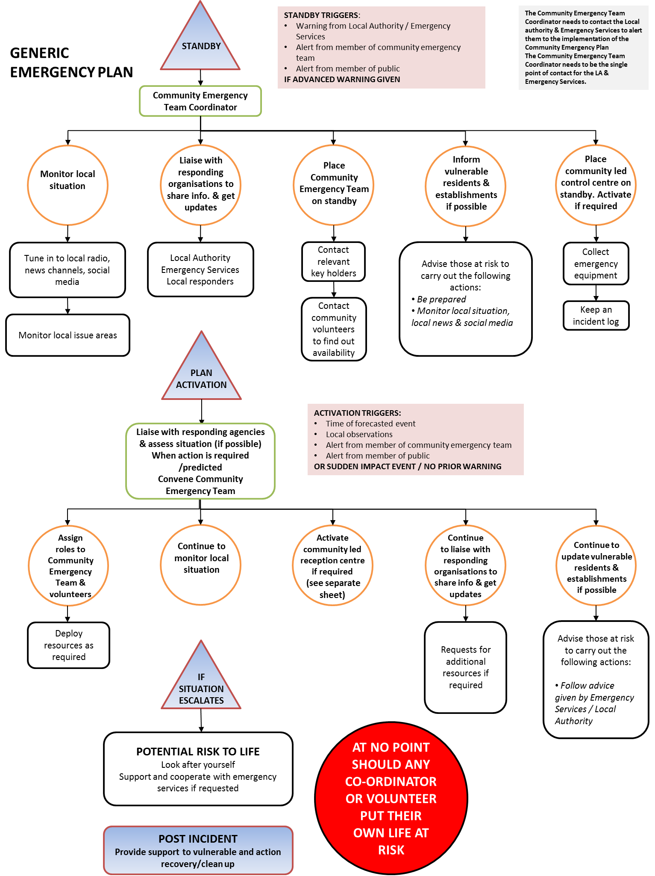

**IMPORTANT NOTES:-**

* **ENSURE THAT YOU REGULARLY UPDATE THE COMMUNITY WITH NON-CONFIDENTIAL, APPROVED INFORMATION.**
* **IF YOU HAVE TO TRAVEL OR GO ANYWHERE ALWAYS ENSURE SOMEONE KNOWS WHERE YOU ARE GOING, APPROXIMATELY HOW LONG YOU WILL BE AWAY, AND HAVE A CONTACT NUMBER BY WHICH THEY CAN CONTACT YOU.**
* **DO NOT PUT YOURSELF OR OTHERS AT RISK.**

**IF EMERGENCY SERVICES ARE ON SITE- WORK WITH THEM - DO NOT OBSTRUCT THEM.**

Intentionally Blank

**6.2ii Flood Emergency Procedure**

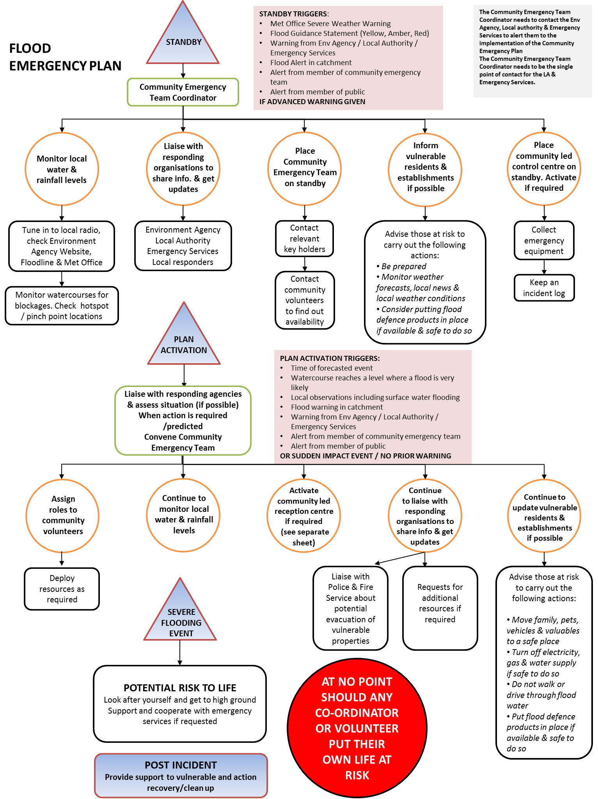

**IMPORTANT NOTES:-**

* **ENSURE THAT YOU REGULARLY UPDATE THE COMMUNITY WITH NON-CONFIDENTIAL, APPROVED INFORMATION.**
* **IF YOU HAVE TO TRAVEL OR GO ANYWHERE ALWAYS ENSURE SOMEONE KNOWS WHERE YOU ARE GOING, APPROXIMATELY HOW LONG YOU WILL BE AWAY, AND HAVE A CONTACT NUMBER BY WHICH THEY CAN CONTACT YOU.**
* **DO NOT PUT YOURSELF OR OTHERS AT RISK.**

**IF EMERGENCY SERVICES ARE ON SITE- WORK WITH THEM - DO NOT OBSTRUCT THEM.**

Intentionally Blank

## 6.3 Rest/Welfare Centre Check Sheet

You are providing a service which will reduce the distress of people removed from their normal environment because of serious danger.

*Note*: Depending upon the nature of the emergency evacuees may be transported to an alternative longer-term site, or found alternative accommodation for the initial duration of the emergency.

**Under no circumstances should you put yourself or others at risk!**

|  |  |  |  |
| --- | --- | --- | --- |
| **No** | **Suggested Considerations** | **Checklist** (Tick) | Remarks/Action Take |
| **Initial Considerations** | | | |
| 1 | Collect Emergency Box if not located at the centre. |  |  |
| 2 | Open logbook to record events, actions and decisions, engage a note-take if possible. |  |  |
| 3 | Nominate who is going to take charge of the Rest Centre. |  |  |
| 4 | Consider the resources needed to manage the number of potential people/evacuees. |  |  |
| 5 | Inspect the building to ensure it is still fit for purpose. E.g. power, heating, structure etc. |  |  |
| 6 | Establish contact with Police/ Local Authority as necessary – get a log number. |  |  |
| Set-up Centre | | | |
| 7 | Use this plan and the Emergency Box contents to organise the RC internal layout. |  |  |
| 8 | Brief staff, and establish regular briefings. |  |  |
| 9 | Ensure all staff have on means of identification (e.g. tabard and ID badge) |  |  |
| 10 | Allocate staff specific roles/ areas of responsibility. |  |  |
| 11 | Designate a supervisor for each area. |  |  |
| 12 | Organise shift working as soon as possible. The busiest areas will need shorter shifts. |  |  |
| 13 | Ensure all staff and volunteers get proper breaks, rest and refreshment away from the main areas. |  |  |
| Running Rest Centre | | | |
| 14 | Ensure everyone entering the RC is registered. Name, age, gender, home address, place from which evacuated (if different), and destination (if known).  ***Template Registration Forms in Emergency Box*** |  |  |
| 15 | Ensure Evacuees are taken inside immediately, are able to sit down and have a (hot) drink. |  |  |
| 16 | Do not try to register people who have more obvious and urgent needs. People are more important than administrative procedures. |  |  |
| 17 | Do not hold on to evacuees longer than absolutely necessary. If they have somewhere to go (relatives or friends), discharge them as quickly as possible, assisting them with transport if necessary. |  |  |
| 18 | Do not allow children or pets to run riot. Quickly allocate closely supervised entertainment areas for children, and separate accommodation for pets. |  |  |

**IMPORTANT NOTES:-**

* **Remember** that Evacuees may be tired, wet, distressed, sick, hungry or in shock. This may cause them to display abnormal behaviour, e.g. be aggressive.
* **Identify quickly anyone having special needs** and see to those immediately; medical welfare, disability, age, nursing mothers- anyone needing any form of additional assistance for any reason.
* **Be alert** for symptoms of delayed shock or severe stress.
* **Keep everyone informed** frequently and regularly of what is happening with non-confidential, approved information.
* **Treat everyone** as an individual, having different rights, attitudes and needs.

## 6.4 Data Protection – Consent Form

Participation in the Community Emergency Plan

I am willing to participate in this scheme and for my personal data to be included as set out below:

|  |  |
| --- | --- |
| **Name** |  |
| **Address** |  |
| **Telephone no** |  |
| **Mobile** |  |
| **Any other relevant info** |  |

I understand that my information may be kept within copies of the plan held by members of the Community Emergency Team and by Category One responders as set out in the Civil contingencies Act 2004) (mainly Local Authorities, the Environment Agency, Emergency Services) and that it will only be used in an emergency situation for purposes of responding to that emergency. Data will be kept securely in accordance with data protection regulations.

|  |  |
| --- | --- |
| **Signed** |  |
| **Date** |  |

## 6.5 Post Incident Debrief form

**Debrief Form**

**Personal details**

|  |  |
| --- | --- |
| **Name:** | **Role:** |

**Role on the Day**

|  |
| --- |
| **In what capacity were you involved?** |

|  |  |
| --- | --- |
| **What aspects of the operation from your own role perspective did not go well and needs further development?** | **What aspects of your own role perspective went well and should be highlighted as good practice for future?** |

|  |  |
| --- | --- |
| **What aspects from the Community Plan perspective did not go well and needs further development?** | **What aspects from the Community Plan perspective went well and should be highlighted as good practice for future?** |

|  |
| --- |
| **List plan amendments here**  **Any other comments.** |