Setting up and using a workstation for a child with autism

A workstation is part of the TEACCH approach which has been used successfully for many years, to teach children with autism. The approach focuses on individual’s strengths to enable them to develop independent learning skills, support weaknesses and to reduce stress.

The workstation incorporates structure, routine, visual cues and limits distraction, to develop independence, organisational skills,
the concept of finished and the generalisation of skills.

Set up a quiet, low distraction area for workstation and teaching activities. A table facing away from the room with a bookcase or cupboard to provide some screening can help. If the same area is used for 1:1 teaching and workstation activities, make sure the pupil knows which he/she will be doing. A small change in the environment can help eg. remove workstation trays and present teaching activities in different manner, using different symbols/words.

A workstation will show the pupil
- What to do (using visual /structural cues eg. a photo of the completed activity)
- How much work to do
- When the pupil will be finished
- What happens next

A good workstation will...
- Only use activities the pupil can do independently and has a high chance of succeeding at
- Use activities which are interesting to the pupil
- Use activities which are presented visually/structurally so pupil knows what to do eg. inset jigsaw, colour sorting items with colour trays to sort into
- Use concrete, practical activities using physical skills
- Require minimal support eg occasional guidance
- Have limited distractions
- Develop organised working pattern eg. top to bottom or left to right

It is best to correct and respond to pupil’s mistakes after workstation time. You may need to simplify task or re- teach a task if pupil needs help. Encourage pupil to leave task completed in the drawer or folder, so adult can check later.

Workstation Structure
- Trays or folders containing activities are placed in drawers or stacked on a shelf/table on pupil’s left side. They are arranged top to bottom . They are numbered or have colour squares to match numbers /colour squares on a strip on table top. Velcro is very useful for attaching numbers.

- Pupil removes top number/colour square from strip and matches to corresponding tray/folder – attach to piece of Velcro on tray/folder.

- Pupil completes activity and then places tray to box or floor on right side, or back into tray storage system, if using.

- Repeat with following drawers/folders

- Once all numbers/colour squares have been removed from strip on table top and activities have been completed, the pupil has finished. A symbol at the bottom of the strip directs them to the next activity or their timetable.

- Some workstations may have a ‘reward’ tray or activity when the pupil has finished , if he/she needs this level of motivation to complete his/her work.

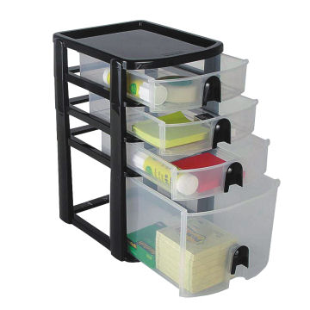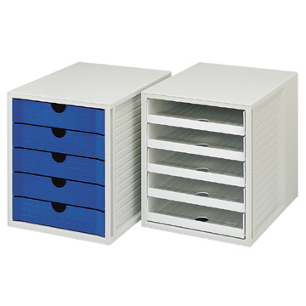

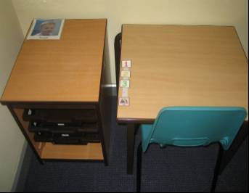

1:1 Structured Teaching Sessions

It is helpful to provide structure for those children with autism who need this approach to focus on the task. These sessions involve children learning new skills, as directed by the adult. Once the pupil has mastered the skill or activity, it can be used in the workstation, as this provides the opportunity to practise and reinforce the learning.

- Use a ‘first/then’ cue card to show the pupil what is expected, or work symbol from their timetable – whichever is most appropriate for the pupil
- Provide a visual structure which shows pupil what they are expected to achieve. Two trays or baskets can be helpful; one labelled ‘to do’ and one labelled ‘finished’, using the appropriate symbols. Some people use green and red trays or baskets (to do/ finished).
- Tasks should be visual and not need lots of explanation, as the pupil may struggle with instructions.
- Tasks should be at the next step in a child’s level of ability/achievement
- Tasks should encourage independence
- Tasks should utilise the pupils interest and be motivating
- 1:1 sessions provide an opportunity to revisit an activity the pupil may find difficult to complete independently
- Use laminated cards of ‘to do’ for more able pupils or a tick list that states what to do, instead of baskets/trays

